18CSC303J – Database Management System Project

Criminal Record Management System

Under the guidance of – Dr. Niranjana G

By -RA1911003010899 Gauri Singh

-RA1911003010892 Aniket Anand

Abstract:

The purpose of the Crime Records Management System is to mechanize the existing manual system with computerized equipment and developed computer software, fulfilling the necessities of all policemen. Their valuable data/information can be stock up for a more extended period with easy access to the same. The required software and hardware are readily available and easy to work with.

This framework likewise keeps up electronic records of all the FIR documented against crime. The principle point of this venture is to tell every single police officer about the arrival of any lawbreaker, including his/her subtleties, for example, criminal's id, name, sort of discharge, etc. Furthermore, it likewise gives the subtleties of any new principle that has been presented or any occasion that is going to occur. It tends to be utilized as an application by the police division to deal with the records of various exercises identified with the First Information Report. In this framework every one of these exercises (like enlistment of the objection, refreshing data) is dealt with that spares time. This application is for the police headquarters that give offices to revealing violations, documenting FIR, and keeping up detainee records. It gives better forthcoming to the improvement of association concerning quality and straightforwardness.

The proposed framework can be utilized in police headquarters over a city where warnings are sent to the police when the criminal is discharged. The point is to slice through the chaos and the remaining burden by advancing the current framework. It advises every workforce with the application on his android telephone, about the arrival of a guilty party, including different subtleties

It kills the current issue where the branch of police of various zone of ward stays ignorant of the arrival of the crook and his/her additional subtleties by making a warning each time there is an arrival of a lawbreaker. This methodology can, in this manner, decrease the exertion of the police and spare their time, which might be utilized profitably.

Modules and Description of Crime Record Management System Project:

Crime Module:

The main aim of this module is provide all the functionality related to crime. This Crime module is an important module in this project Crime Record Management System Project in dbms which has been developed on MySQL.

Features of Crime Module:

* Admin can add new crime
* Admin can see the list of crime details
* Only admin can edit and update the record of the crime
* Admin will be able to delete the records of the crime
* All crime forms are validated on client side.

Criminal Module:

The main aim of this module is to provide all the functionality related to criminals It tracks all the information and details of the criminal We have developed all type of CRUD (Create Read update and delete) operations of the criminals. This is a role-based module where admin can perform each and every operation on data but the criminal will be able to view only her data access level restrictions been implemented on the project

Features of Criminal Module:

* Admin can add new criminals records
* Admin can see the list of criminals details
* Only admin can edit and update the record of the criminals
* Admin will be able to delete the records of the criminals
* All criminals forms are validated on client side
* criminal will be able to see his details
* criminal will be able to update his details

Functionality performed by admin user:

These are the functionality performed by the admin users.

• Login For Admin

• Forgot password for Admin

• Edit Profile For Admin

• Manage Crime

• Adding New Crime

• View Profile of the Crime

• Listing of all Crime

• Manage Criminal

• Manage System User

* Edit the Exiting Crime
* Adding New System User
* Edit the Exiting System User
* View Profile of the System User
* Listing of all System User
* Reports of the project Crime Record Management System
* Report of all Crimes
* Report of all Criminals
* Report of all System Users

Static Pages and other sections:

These static pages will be available in project Crime Record Management System

• Home Page with good Ul

• Home Page will contain an animated slider for images banner

• About us page will be available which will describe about the project

Contact us page will be available in the project

Technology Used in the project Crime Record Management System

We have developed this project using the below technology

• HTML Page layout has been designed in HTML

• CSS: CSS has been used for all the desigining part

• JavaScript: All the validation task and animations has been developed by JavaScript

• MySQL MySQL database has been used as database for the project.

• Tomcat: Project will be run over the Tomcat server

Supported Operating System

We can configure this project on following operating system.

• Windows: This project can easily be configured on windows operating system. For running this project on Windows system, you will have to install Tomcat 7, JDK 7, MySQL 5.

• Linux: We can run this project also on all versions of Linux operating system

• Mac: We can also easily configure this project on Mac operating system.

Table design for complaint report:

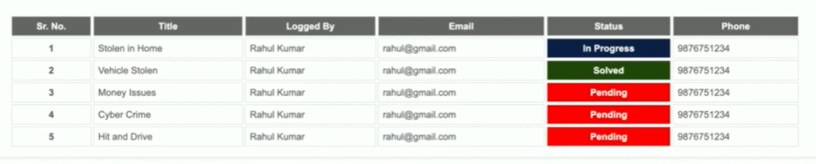

Table design for Police user report

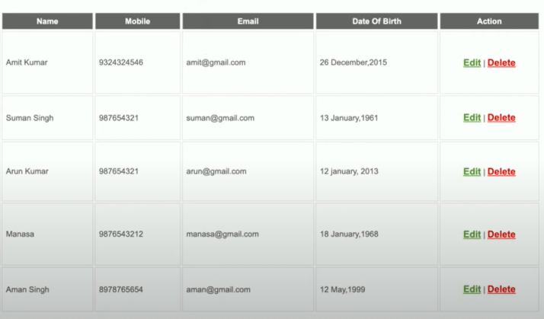

ER Diagram:

